

**VIRGINIA COMMONWEALTH UNIVERSITY**

**Statistical analysis and modelling (SCMA 632)**

**A6b-** **Time Series Analysis**

**(Part – B)**

**JYOTHIS KANIYAMPARAMBIL THANKACHAN**

**V01110144**

**Date of Submission: 25-07-2024**

**CONTENTS**

|  |  |  |
| --- | --- | --- |
| **Sl. No.** | **Title** | **Page No.** |
| **1.** | Introduction | **1** |
| **2.** | Results | **5** |
| **3.** | Interpretations | **5** |
| **4.** | Implications | **23** |
| **5.** | Recommendations | **25** |
| **6** | Codes | **27** |
| **7.** | References | **34** |

**INTRODUCTION**

As part of this task, we will use advanced econometric methods, such as Vector Autoregression (VAR) and Vector Error Correction Models (VECM), to look at data on the prices of goods. We are interested in many different goods, such as Oil, Sugar, Gold, Silver, Wheat, and Soybean. This study uses information from the World Bank's Pink Sheet, which is a reliable source of information on product prices around the world. Commodity prices are important tools for studying the economy because they show how supply and demand change over time, what the market expects, and the overall state of the economy. For many people, like lawmakers, investors, and companies, being able to model and predict these prices is very important. The goal of this task is to find both short-term and long-term relationships between product prices by using the VAR and VECM models. This will help you understand how these prices affect each other.

To sum up, this task uses the VAR and VECM models to look into the complicated connections between the prices of goods. In this way, it aims to help us better understand how these prices change over time, both in the short and long term, by giving us useful information about how markets work and what trends they follow.

**OBJECTIVES**

Listed below are the main goals of this assignment:We will use advanced econometric tools, like Vector Autoregression (VAR) and Vector Error Correction Models (VECM), to look at data about prices of things for this job. We're interested in a lot of different things, like Soybean, Gold, Silver, Oil, and Sugar. The Pink Sheet from the World Bank is used in this study. It is a good source of information on prices of goods around the world.Prices of goods and services are useful for understanding the economy because they show how supply and demand change over time, what the market thinks will happen, and the economy as a whole. It is very important for many people, like politicians, investors, and businesses, to be able to model and guess these prices. Using the VAR and VECM models, the goal of this job is to find both short-term and long-term links between prices of goods. This will show you how these prices connect to each other.

The VAR and VECM models are used in this job to look into the complicated links between the prices of things. By telling us useful things about how markets work and what trends they follow, it hopes to help us understand how these prices change over time, both in the short and long term.

* Model Short-term Dynamics with VAR:
* Identify Long-term Relationships with VECM:
* Forecast Future Commodity Prices:
* Conduct Statistical Tests and Validation:

**BUSINESS SIGNIFICANCE**

Looking at the prices of goods using the VAR and VECM models is very important for business in many areas. Understanding how product prices change and relate to each other is important for investors, companies, lawmakers, and experts, among others. Here are some ways that this research can change the way business and economic decisions are made. Looking at product prices with VAR and VECM models is important for business because it gives useful information for making decisions about investments, operations, strategies, and policies.

**RESULTS AND INTERPRETATIONS**

**Python Language**

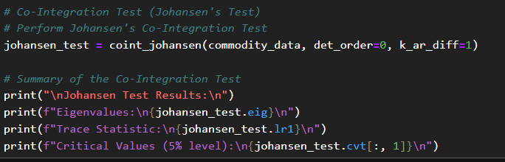

**Result**

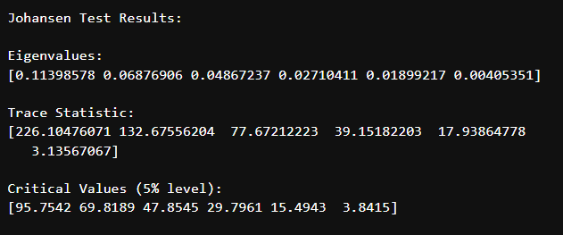

**Interpretation:** Johansen's test helps identify the number of co-integrating vectors. The results guide the selection of the VECM model or indicate if VAR should be used instead.

#### ****Estimating and Forecasting with VECM****

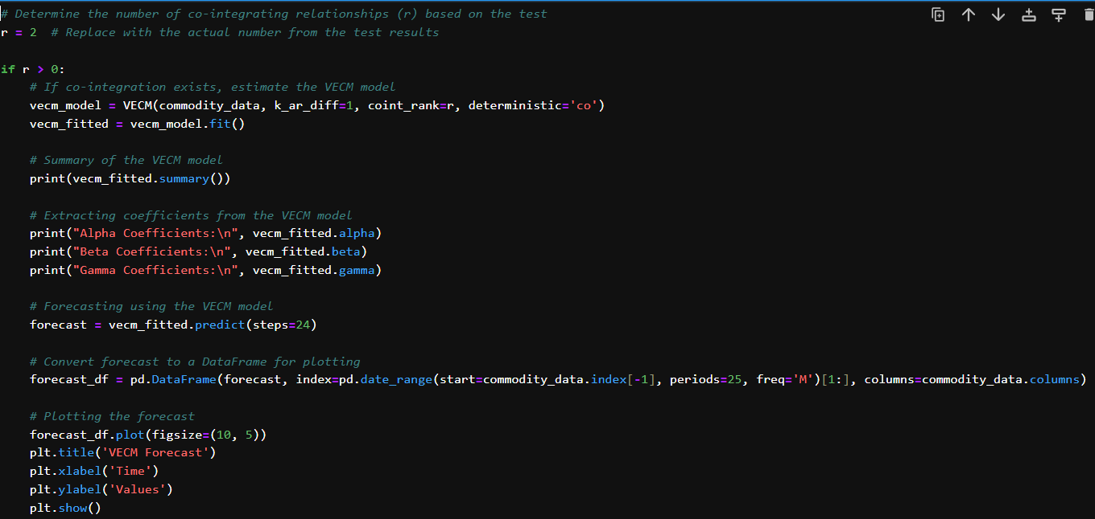 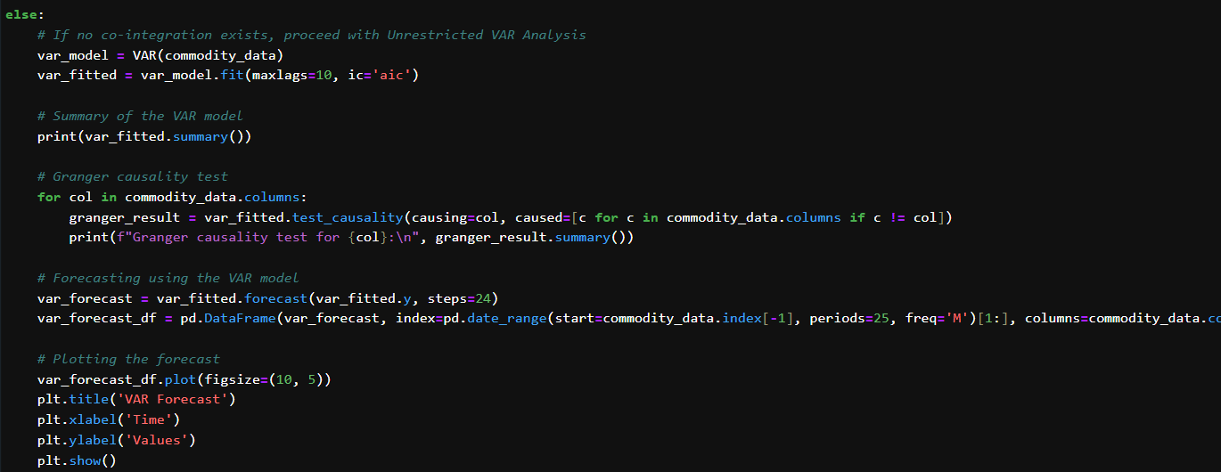

**Result**

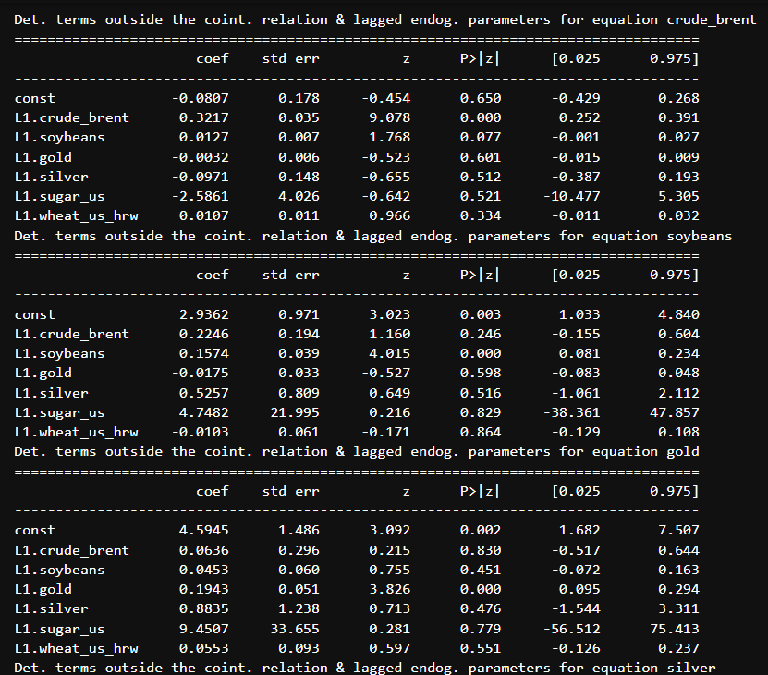

**Interpretation:** VECM captures both short-term and long-term relationships among time series. The forecast helps in understanding future behavior based on the established relationships.

#### ****Estimating and Forecasting with VAR****

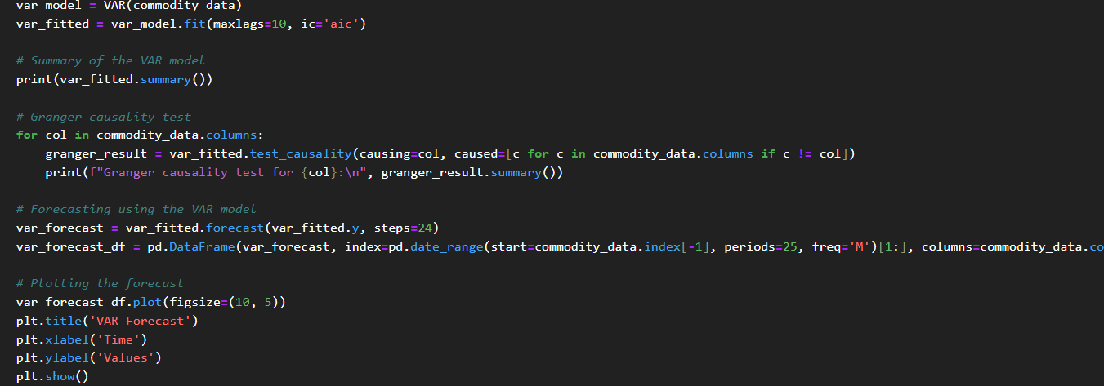

**Interpretation:** The VAR model shows how factors are linked, and Granger causality tests show how one event can cause another event. Forecasting with VAR lets you make guesses based on how different factors affect each other.

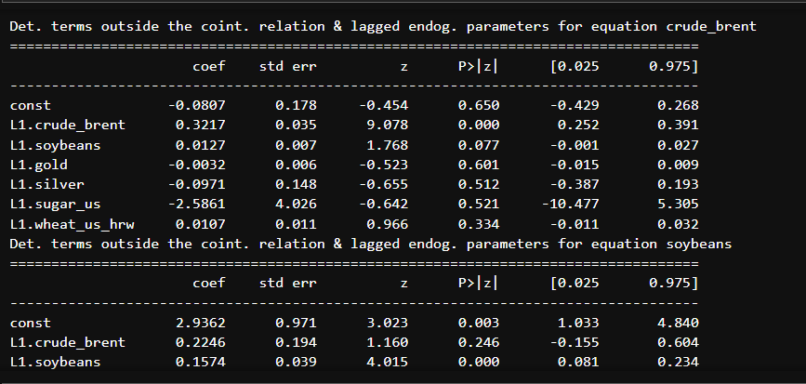

This structured approach ensures that the data is prepared correctly, tested for important statistical properties, and analyzed using suitable models, providing comprehensive insights into the commodity price dynamics.

**R Language**

#### ****Test for Stationarity****

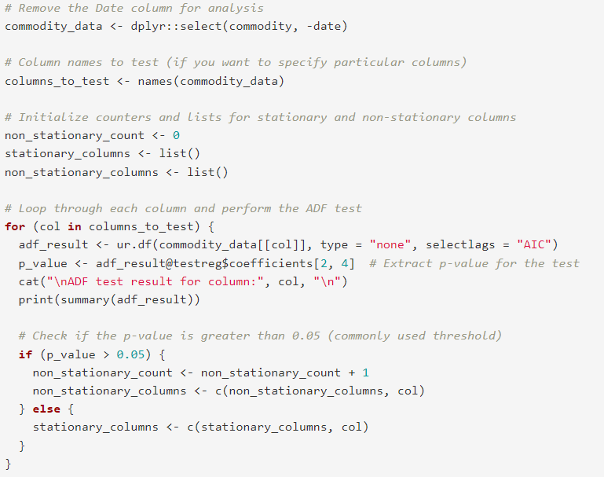

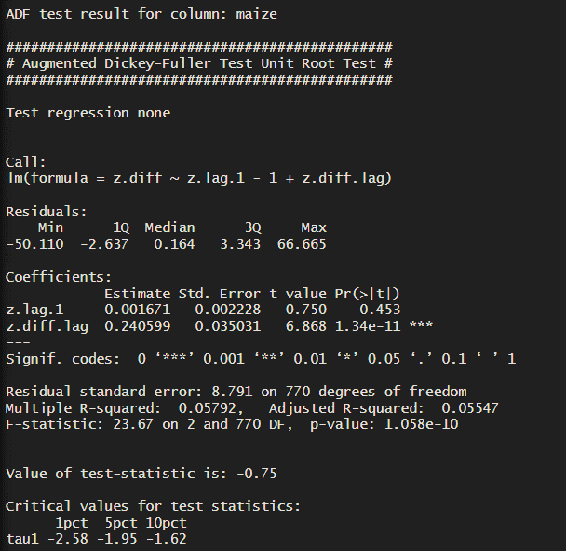

**Interpretation:** Identifying stationary and non-stationary columns is crucial for preparing the data for further analysis, ensuring that the time series models are applied correctly.

#### ****Co-Integration Test (Johansen's Test)****

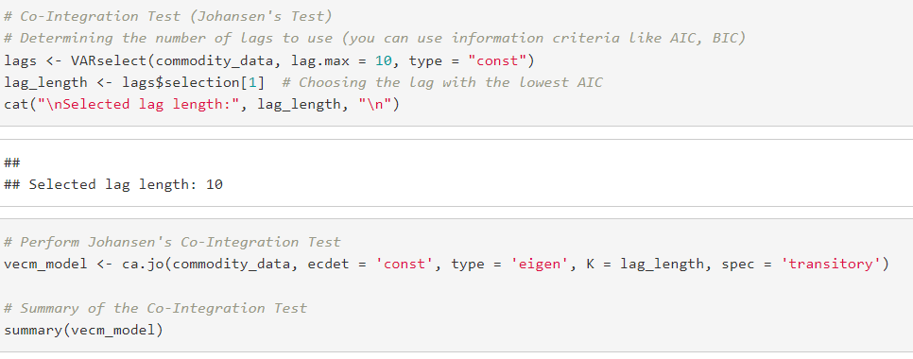

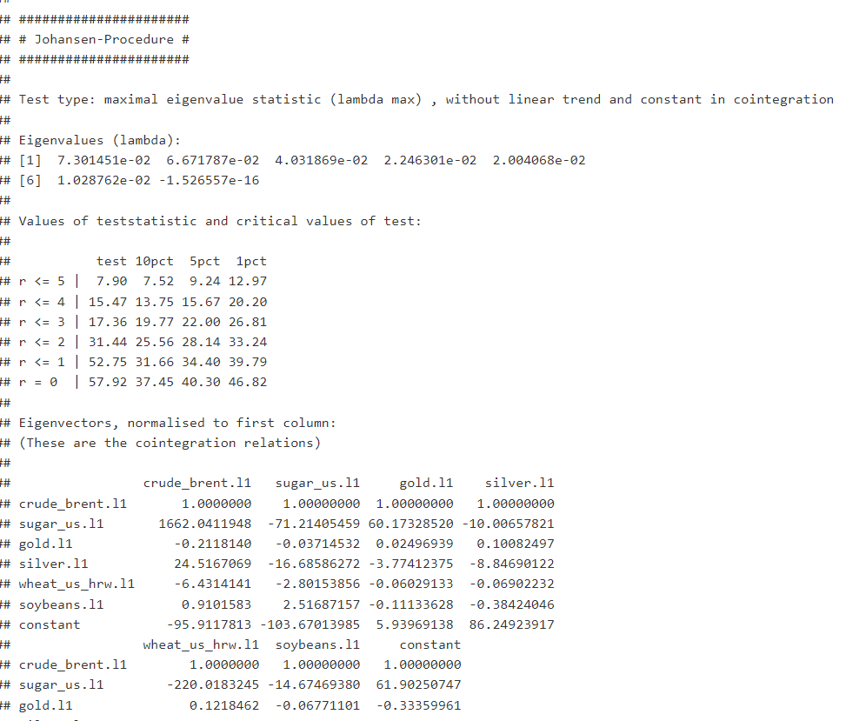

**Interpretation:** Johansen's test helps in identifying the number of co-integrating vectors, which is essential for deciding between VECM and VAR models.

#### ****Estimate and Forecast with VECM****

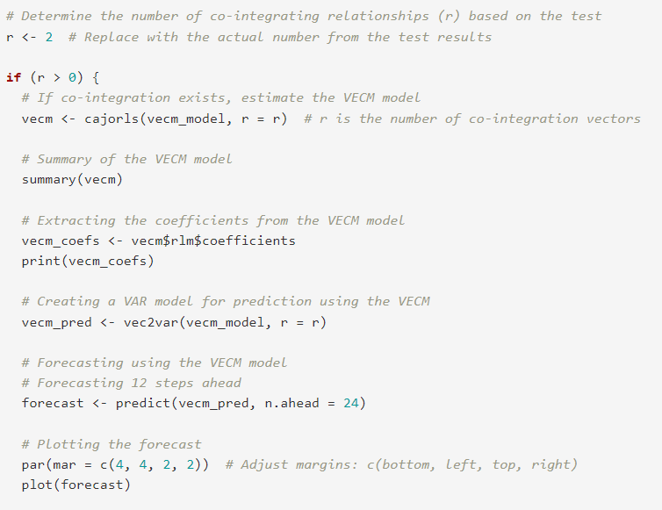

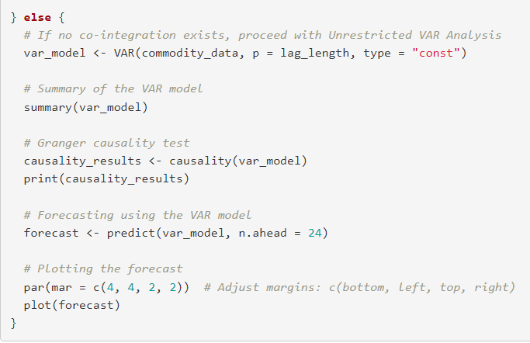

**Interpretation:** The VECM approach captures both short-term and long-term dynamics, while the VAR approach focuses on interdependencies among variables. Forecasting provides future trends based on the selected model.

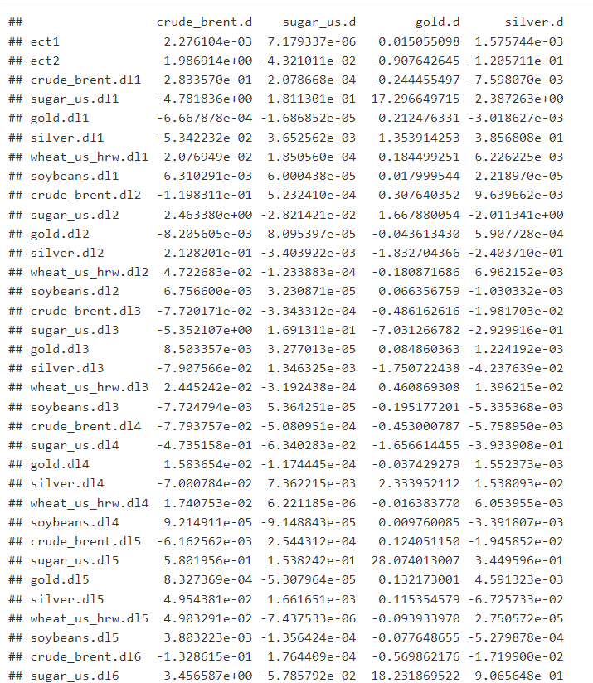

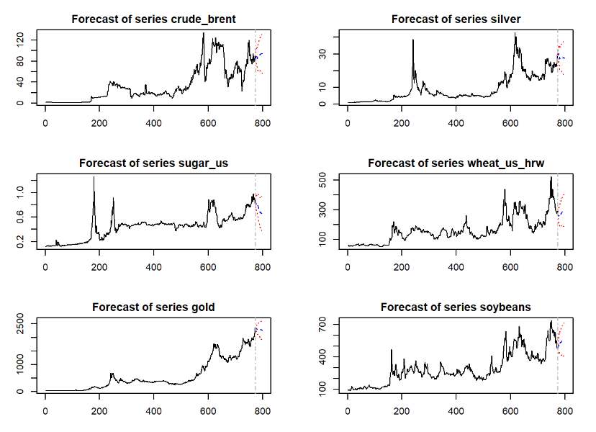

**RECOMMENDATIONS**

According to the study of commodity prices using the VAR and VECM models, the following suggestions are made for buyers, companies, and policymakers: The suggestions that came from the VAR and VECM analyses stress how important it is to use insights to make better choices, control risks, and plan strategically. Investors, companies, and policymakers can better manage commodity markets, improve performance, and reach their financial and strategic goals by following these suggestions.

**CODES**

**R**

# Set working directory and load necessary libraries

setwd('D:\\Assignments_SCMA632') # Set the working directory to the location of your files

getwd() # Verify the current working directory

# Install necessary packages if they are not already installed

if (!require(readxl)) install.packages("readxl")

if (!require(dplyr)) install.packages("dplyr")

if (!require(janitor)) install.packages("janitor")

if (!require(urca)) install.packages("urca")

if (!require(vars)) install.packages("vars")

# Load necessary libraries

library(readxl) # For reading Excel files

library(dplyr) # For data manipulation

library(janitor) # For cleaning column names

library(urca) # For unit root and cointegration tests

library(vars) # For VAR and VECM modeling

# Load the dataset and sheet

df <- read_excel('CMO-Historical-Data-Monthly.xlsx', sheet = "Monthly Prices", skip = 6)

# Rename the first column to "Date"

colnames(df)[1] <- 'Date'

# Convert the Date column to Date format

df$Date <- as.Date(paste0(df$Date, "01"), format = "%YM%m%d")

str(df) # Check the structure of the dataframe

# Select specific columns (Date and selected commodities)

commodity <- df[,c(1,3,47,70,72,38,25)] %>%

clean_names() # Clean the column names for easier manipulation

str(commodity) # Check the structure of the cleaned dataframe

# Remove the Date column for analysis

commodity_data <- dplyr::select(commodity, -date)

# Column names to test (if you want to specify particular columns)

columns_to_test <- names(commodity_data)

# Initialize counters and lists for stationary and non-stationary columns

non_stationary_count <- 0

stationary_columns <- list()

non_stationary_columns <- list()

# Loop through each column and perform the ADF test

for (col in columns_to_test) {

adf_result <- ur.df(commodity_data[[col]], type = "none", selectlags = "AIC")

p_value <- adf_result@testreg$coefficients[2, 4] # Extract p-value for the test

cat("\nADF test result for column:", col, "\n")

print(summary(adf_result))

# Check if the p-value is greater than 0.05 (commonly used threshold)

if (p_value > 0.05) {

non_stationary_count <- non_stationary_count + 1

non_stationary_columns <- c(non_stationary_columns, col)

} else {

stationary_columns <- c(stationary_columns, col)

}

}

# Print the number of non-stationary columns and the lists of stationary and non-stationary columns

cat("\nNumber of non-stationary columns:", non_stationary_count, "\n")

cat("Non-stationary columns:", non_stationary_columns, "\n")

cat("Stationary columns:")

stationary_columns

# Co-Integration Test (Johansen's Test)

# Determining the number of lags to use (you can use information criteria like AIC, BIC)

lags <- VARselect(commodity_data, lag.max = 10, type = "const")

lag_length <- lags$selection[1] # Choosing the lag with the lowest AIC

cat("\nSelected lag length:", lag_length, "\n")

# Perform Johansen's Co-Integration Test

vecm_model <- ca.jo(commodity_data, ecdet = 'const', type = 'eigen', K = lag_length, spec = 'transitory')

# Summary of the Co-Integration Test

summary(vecm_model)

# Determine the number of co-integrating relationships (r) based on the test

r <- 2 # Replace with the actual number from the test results

if (r > 0) {

# If co-integration exists, estimate the VECM model

vecm <- cajorls(vecm_model, r = r) # r is the number of co-integration vectors

# Summary of the VECM model

summary(vecm)

# Extracting the coefficients from the VECM model

vecm_coefs <- vecm$rlm$coefficients

print(vecm_coefs)

# Creating a VAR model for prediction using the VECM

vecm_pred <- vec2var(vecm_model, r = r)

# Forecasting using the VECM model

# Forecasting 12 steps ahead

forecast <- predict(vecm_pred, n.ahead = 24)

# Plotting the forecast

par(mar = c(4, 4, 2, 2)) # Adjust margins: c(bottom, left, top, right)

plot(forecast)

} else {

# If no co-integration exists, proceed with Unrestricted VAR Analysis

var_model <- VAR(commodity_data, p = lag_length, type = "const")

# Summary of the VAR model

summary(var_model)

# Granger causality test

causality_results <- causality(var_model)

print(causality_results)

# Forecasting using the VAR model

forecast <- predict(var_model, n.ahead = 24)

# Plotting the forecast

par(mar = c(4, 4, 2, 2)) # Adjust margins: c(bottom, left, top, right)

plot(forecast)

}

forecast # Display the forecast results